Birla Institute of Technology & Science, Pilani
Work Integrated Learning Programmes Division
Second Semester 2021-2022

Mid-Semester Test
(EC-2 Regular)

Course No. : SS ZG514
Course Title : OBJECT ORIENTED ANALYSIS AND DESIGN
Nature of Exam : Open Book
Weightage : 30%
No. of Pages = 02

No. of Questions = 03
Duration : 2 Hours
Date of Exam : 13/03/2022 (FN)
Note to Students:
- Please follow all the Instructions to Candidates given on the cover page of the answer book.
- All parts of a question should be answered consecutively. Each answer should start from a fresh page.
- Assumptions made if any, should be stated clearly at the beginning of your answer.

- Draw a use case diagram corresponding to this detailed use-case given below:
An insurance brokerage company has contracted you to build an application allowing clients to apply for life insurance online. This brokerage firm sells insurance policies on behalf of the life insurance company, (say LIC). A detailed use-case of the brokerage software is given below:
[10 Marks]
Apply for a life insurance
Main success scenario
- Customer selects desired insurance plan.
- System determines if client qualifies for selected plan.
- Customer fills in the online application form.
- Customer submits the application.
- Validator checks that all fields are filled and the data is valid.
- Payment processor authorizes transaction with bank.
- Payment processor performs transaction with the bank.
- System saves the approved application.
- System notifies client and LIC of the new coverage.
Extensions
2a. client does not qualify, show an error message.
5a. data missing or invalid show an error message.
6a. payment authorization failed, show and error message.

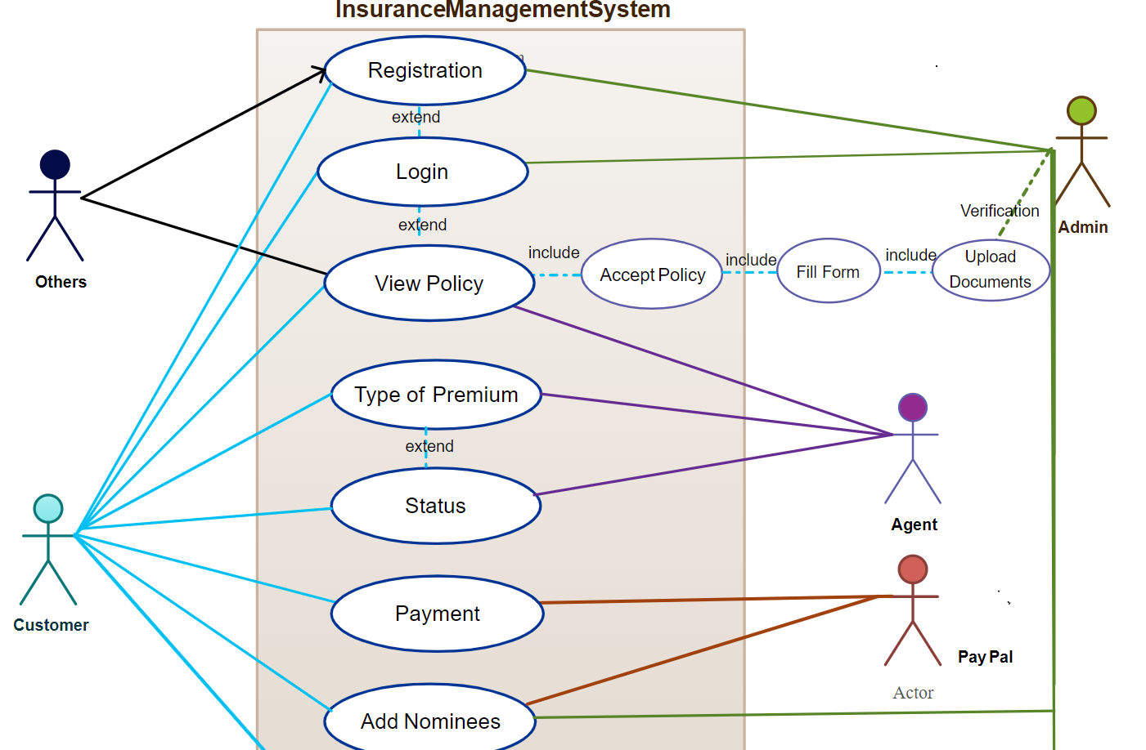

- A cricket league is made up of eight cricket teams. Each cricket team has 11 to 14 players. One player is a captain of the team. Each team has one coach. The team’s coach has accreditation level and years of experience. Each team has a name and a record. Similarly, each player has a number and a position. The games played between two teams have a location and scores of each team. Coaches and the players are people with names, age, and nationality. You have to draw a conceptual (domain) class diagram for this information. Don’t forget to label the associations with appropriate cardinalities. [10 Marks]

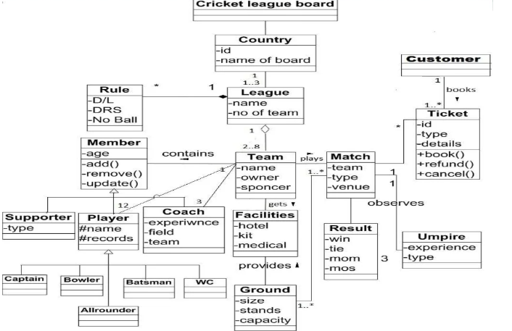
- Read the description of an Elevator Management System below and draw a Sequence diagram referring to the floor button.
An embedded system is to be installed in a building with ten floors to control elevators. The elevator has one button for each floor. The buttons glow when they are pressed. As a result, the elevator visits the corresponding floor. The lights on the buttons turn-off when the elevator reaches the corresponding floor. Except for the tenth and the first floors, all other floors have two buttons – one button is to request the elevator go up, and the other is to ask the elevator going down. We can call them UP and DOWN buttons, respectively. The UP and DOWN buttons glow when they are pressed. The UP and DOWN buttons cease to glow when the elevator reaches that floor and starts moving in the requested direction. The elevator remains stationed on the current floor with its doors closed if there are no requests. The main actions of the elevator are listed below:
- Floor button is pressed by the user.
- Floor button pressed is detected by the elevator.
- Elevator starts moving to the requested floor.
- The doors of the elevator open up.
- The users press the button inside the cabin panel of the elevator.
- The doors of the elevator get closed.
- The elevator starts moving UP or DOWN to the desired floor.
- The doors of the elevator open up.
- Users safely get out of the elevator.
- The doors of the elevator get closed. [10 Marks]

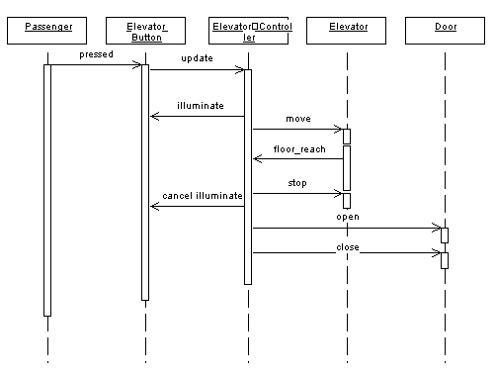

***** Best of Luck *****

